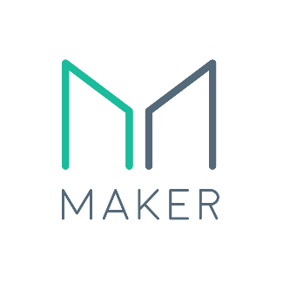
Coin Spotlight MakerDao
10 February 2019
This week, we are looking into Makerdao (Maker), one of the oldest projects being built on the Ethereum network. Maker is an example of building a critical infrastructure layer of the decentralised global economy; an accessible digital cash system native to the internet which maintains price stability via decentralised governance and autonomous smart contracts. Bitcoin meets almost all of the metrics of a useful currency with a crucial exception of price stability due to its fixed supply and deflationary nature. DAI aims to implement this final pillar of price stability with aspiration of becoming the global reserve currency of the decentralised web.

This is a mammoth task and one which Maker has made commendable progress towards achieving. However, the project faces a number of challenges including adoption, scalability and technical barriers which in many cases, are intrinsically linked to existential risks to the cryptocurrency industry and the Ethereum network. Maker is definitely a project to watch with an impressive vision and ethos and an equally impressive barrier to overcome – user adoption and displacing the USD reserve currency.

Project description
The Maker network is aiming to create a stablecoin asset (DAI) which is backed, not by traditional assets such as fiat or gold, but by the trust in autonomous and open source smart contracts, decentralised governance and credit issued against the value of other digital assets.

To achieve this, Maker utilises a two token system:
- DAI – a stablecoin intended to act as a digital cash which is native to the decentralised internet. The goal of DAI is to be a useful, accessible and stable token for payments and a vehicle for savings including appreciation via the “DAI savings Rate” when locked in a savings contract.
- MKR – the governance token which enables a decentralised network of people to assess and manage risk in the market by assigning key parameters to the Maker stability system. MKR holders effectively act as the “lender of last resort” and can be seen to fulfil a role as the central bank of the Maker ecosystem.

The collatoralised debt position
DAI is minted when users of the Maker platform create what is known as a collateralised debt position (CDP). A user puts up collateral (currently ETH, soon to be multi-asset collateral) against which a position of DAI may be borrowed up to the debt ceiling (currently 50% for ETH).

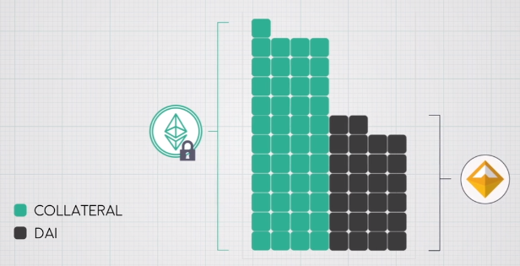
Figure 1 - An example of the CDP mechanism where the amount of DAI borrowed against the collateral asset (ETH) is less than the total collateral value (currently 50%) to maintain a price buffer to price shocks in the collateral asset
This process allows the user to maintain their original asset position without having to sell it to access additional funds. The generation of a CDP comes with a stability fee (an interest rate) and a liquidation ratio at which point the collateral will be automatically sold off by the Maker smart contract if the value of the collateral falls too far relative to the DAI debt (i.e. if price collapses of the ETH collateral such that the DAI debt against it hits the liquidation point).

The MKR governance is responsible for assessing the expected risk and volatility in the market for each collateral asset so as to assign an appropriate debt ceiling and liquidation ratio. Additionally, MKR holders define the stability fee (interest rate) which affects how expensive it is to open a CDP and controls the supply and demand of DAI as well as which assets may be used as collateral.

DAI price falls MKR Increase Stability Fee
Creating CDPs becomes more expensive
Fewer CDPs = reduced DAI supply
Holding DAI increases in capital gains
Demand for DAI increases (pay CDP debt cheaply)
Price of DAI increases to Target Price (peg)
DAI price too high MKR Decrease Stability Fee
Creating CDPs becomes cheap
More CDPs = increased DAI supply
Holding DAI reduces capital gains
Demand for DAI decreases (take on CDP debt bonus)
Price of DAI decreases to Target Price (peg)
Figure 2 - Overview of the Stability Fee decision making process by MKR holders (left graphic borrowed form Ray Dalio)
In effect, MKR holders act as the central bank setting interest rates and trigger levels for liquidation and engagement of stability mechanisms to control the supply and demand for DAI and thus maintain a stable valuation (currently a peg 1:1 to the USD).

The flip side to this, is that should MKR holders misjudge risk in the market and a price shock throws DAI significantly out of balance with the Target Price, the value of MKR will be diluted by printing MKR tokens and selling them via an automatic auction mechanism. This generates the required funds to cover the CDP liquidations and bring the system back into balance.

Essentially MKR holders are the lender of last resort. As payment for their services and responsibility, MKR holders are rewarded by appreciation of their MKR token value as the stability fees and liquidation fees are used to buy back and burn MKR tokens, reducing their supply

A perspective on the dai peg system
The uniquely valuable element of a decentralised stability system is that eventually, a peg to any index can be achieved. This sets Maker apart from the majority of competing stable-coins today which are backed 1:1 with actual USD.

I see 1:1 with USD simply as a convenient bootstrap phase until enough of the world is tokenized to facilitate a DAI peg transitioning to a token representing a diverse basket of digitised assets. This basket would have risk defined proportions and correlations determined by MKR governance and could contain assets or various correlations ranging from commodities, precious metals, digital assets, stock indexes and debt instruments. This basket could be designed and dynamically adjusted based on real time analysis of relevant markets to a point of near immunity to significant price shocks globally creating an impressively stable and truly trustworthy DAI.

This has the potential to completely decouple the decentralised economy from governments and national pressures and truly mark an evolution in global finance. A fairly exciting proposition if you ask me.

CHallenges and Risks
The Maker projects has a number of key risks and challenges to overcome, most of which are reliant on the adoption of DAI as a useful currency. In effect, if DAI must prove itself as a simple to use and reliable stable-coin in order to promote adoption of DAI and the opening of CDPs.

- Access to reliable price data feeds and oracles – Current governance conference calls (available on Maker’s Youtube channel) are focused on the unreliability of price data for DAI obtained from exchanges and CMC due to manipulated and fake volume. This impedes the ability of the Maker system to act appropriately and make evidence based decisions on potential price shocks and volatility.

- Scalability - demand for MKR is driven by the demand for CDPs. If not enough debt is taken on within the system, the available DAI is limited and thus scalability to a global currency will be a challenge. In my opinion, this relies on the assets available as collateral to be both diverse and of high liquidity, having low volatility and thus high debt ceilings. It relies on users owning these collateral assets and be willing to take CDP debt against them. I fear this is a tall order to become a global reserve currency it is no easy feat to engage enough people with the knowhow and risk management skills to take on sufficient CDPs to feed the worlds demand for stability. This may be a challenge that is resolved in time but will require some clever engineering of the system economics and an extremely intuitive, accessible and “fool-proof” user experience.

  - As a final note on scalability – the necessity for CDPs to be overcollateralised sets a natural limit on the amount of debt the world could take on. I propose that perhaps this is not such a bad thing as it would limit irresponsible lending and many of the financial woes we see on a too frequent basis.

- Market Direction - Opening CDPs are only advantageous when the collateral assets are appreciating or stable in value. During a bear market, if a diverse range of negatively correlated collateral are not available, the pool of collateral suitable for a CDP reduces and thus DAI supply will fall. Demand for CDPs would need to be increased by MKR governance lowering the stability fee. However, this is compounded by risk 2 where if not enough users or suitable collateral assets are available, the system could become underutilised and ultimately an alternative stablecoin with simpler user experience would be preferred. Essentially, Maker is co-dependent on the “tokenization of the world thesis” such that assets of varying risk profiles, volatility and correlation are available as collateral.

- Reliance on Ethereum - Maker is currently tied intrinsically to Ethereum which whilst certainly a groundbreaking platform, suffers from key issues of horrendous user interface (this is so important for adoption), poor scalability and heavy competition. Many of these are technical challenges likely to be solved in the future however, the potential for a vastly superior platform emerging in the meantime is a very real existential risk to the project and Ethereum network. Whilst I am not a developer, I understand the Maker project to be smart contract heavy and I’ve not yet seen evidence of flexibility to port to new a new decentralised ledger if the need arises.

- Stabilisation of DAI in normal circumstances (i.e. outside of MKR governance intervention) is currently dependent on market forces such as:
  - Arbitrage trading when DAI deviates from the Target Price
  - CDP owners buying DAI below Target price to pay back debt cheaply
  - Users creating CDPs when DAI is above target price to sell into the market
This is a somewhat reactionary model and again is heavily reliant on adoption and trade volume of DAI to the extent that the market will act to quickly capitalize on these price fluctuations. Whilst possible, this is something that is currently not occurring and in conjunction with a lack of accurate data feeds (risk 1) is making current MKR governance an inexact science.

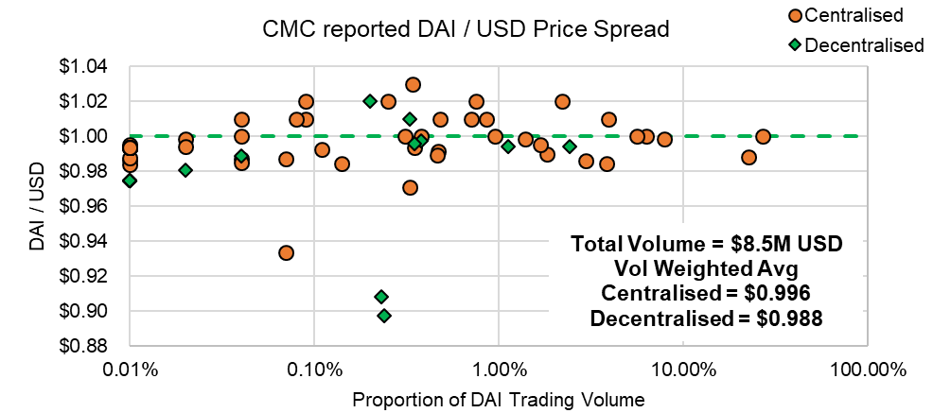
Figure 3 - Example showing DAI price is generally within 2 cents of the target price across CMC reported markets. This question is how much of this volume is real and reliable for making decisions?

- Market Exposure is currently limited with a trading volume of DAI against all pairs at the time of writing of only $8.5Million (from CMC price feeds). This makes the arbitrage opportunities relatively limited at the moment. However I am more excited by the prevalence of DAI on decentralised and peer-to-peer exchanges such as Airswap, Bancor and Kyber Network which currently account for 50% of DAI market volume. It is also impressive that 1.5% of the total Ether supply is currently locked in CDPs. One would hope that with improvements to the UI of both Ethereum and Maker and with continued development, this number will only grow.

Opportunities
Against a backdrop of significant challenges, Maker has major opportunities in this space as it is at the fundamental level providing an essential component of the decentralised economy – access to secured credit. To date, DAI has shown fairly robust stability maintaining a peg within a few cents of the target 1:1 USD peg and time will tell if it can maintain this as the Maker platform gains traction.

- Decentralised governance of a central banking system is immune to the influences of politics and national pressures and acts only to support the Maker and wider crypto networks. This is a crucial layer of the decentralised internet and the role of DAI as a “global reserve currency” will not be subject to the Triffin Dilemma. This is a distinct advantage over “USD backed” stable-coins such as USDT, USDC which are subject to the stability of the US economy.
  - In my opinion, the challenge of creating new a decentralised central bank is an enormous challenge…dwarfed only by the enormity of the opportunity this represents during the inevitable(?) collapse of the fiat system when people flee in search of a better and more transparent money. If we see instability in the USD in the future – I will be watching Maker and DAI with a keen eye for signs of capital flight.

- Open Source and Transparent rules governing the protocol are agreed by MKR holders based on scientific evidence of market behavior and made transparent via open source code. This fits perfectly with Satoshi’s vision of an immutable and verifiable financial system and Maker has the right vision and approach to this problem.

- Partnerships with the likes of OmiseGo (OMG) and Request Network (REQ) are in the works with the intent for DAI to be available facilitate payments on both of these projects (themselves building critical infrastructure for the Ethereum network). Maker developers are open to being symbiotic with the Ethereum ecosystem which is a growing trend in this industry and an immense opportunity.

- Global accessibility to CDPs enables people around the world to take on reasonable leverage of their assets which is aligned with the ethos of the decentralisation and financial freedom movements. CDPs are a well-established mechanism within the credit system and is an essential part of a growing economy. Maker provides a financial solution for the 2Billion underbanked people who collectively represent $10 Trillion in productivity (the informal economy is the third biggest global economy).

- Synthetic derivate products such as index funds of CDP assets are planned for the Maker platform via a reverse CDP where volatile assets can be created by locking up stable DAI. It will be interesting to see how this fairs against the likes of dYdX and other “basket” products as Maker has an opportunity in this space but DAI must be an proven and attractive overall product for this branch to succeed.

- Sustainable Development – Maker is a project which announced in 2015, launched Dai in December 2017 and unlike many projects, did not have an ICO, instead opting for venture capital investments in two rounds ($15M and $12M). Maker has shown continued progress towards their goals, setting realistic and achievable goals and delivering a product fit for purpose. The incentives for success of the platform are aligned between developers and investors and the approach is targeting a self-sustaining ecosystem.

Final Thoughts
There are growing signals of DAI adoption and I would recommend checking out this report from Maker to see some of the latest adoption numbers as well as this three part series on governance and platform challenges. Overall, Maker is a bold project with a clear vision which to date is one of the most valuable contributions to the decentralised internet. I look forward to Makers future and hope too see some flexibility and futureproofing start to find it’s way into focus for the team.

The model of CDP backed stability is a sound and well documented credit system with the Maker twist of being governed in a decentralised manner. The biggest challenge for Maker today are the limited assets available to form collateral which today are unfortunately all correlated to the crypto industry. In the future, if our thesis is correct and the whole world becomes tokenised, pegging Dai to an index basket of diverse assets would provide groundbreaking opportunities.

Time and technological development is a factor here as whilst Maker currently enjoys a first mover advantage a competitor to both Maker and Ethereum itself could be just around the corner.

Resources
Positive opinions | https://www.youtube.com/watch?v=2lxc7qCsvF8  https://medium.com/makerdao/makerdao-and-omisego-announcing-dai-and-omg-collaborations-23600a080046  https://medium.com/makerdao/makerdao-integrates-with-request-network-to-promote-stability-in-cryptocurrency-finance-b1f52aba6a1  https://thecontrol.co/lessons-from-makerdao-a42081116e9a  https://medium.com/makerdao/makerdao-governance-risk-framework-38625f514101  https://medium.com/makerdao/dai-reward-rate-earn-a-reward-from-holding-dai-10a07f52f3cf  https://www.crunchbase.com/search/funding_rounds/field/organizations/num_funding_rounds/makerdao  https://medium.com/makerdao/dai-in-numbers-2710d8a5633a
Critical opinions | https://medium.com/reserve-currency/our-analysis-of-the-makerdao-protocol-4a9872c1a824  https://blog.havven.io/makerdao-and-the-dai-f21a4d5571a1

